200687M Vishwamith P.G.H Assignment 1

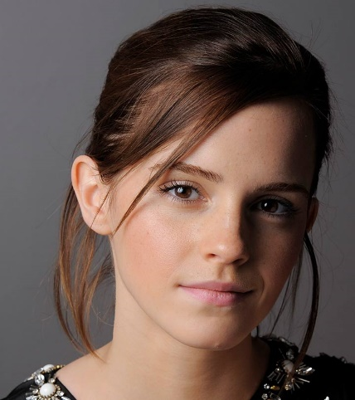1)

Intensity Transformation

Original Image

Transformed Image

Pixel with Intensity between 150 – 50 have enhanced. Other Intensity values haven’t changed since it’s a y=x line.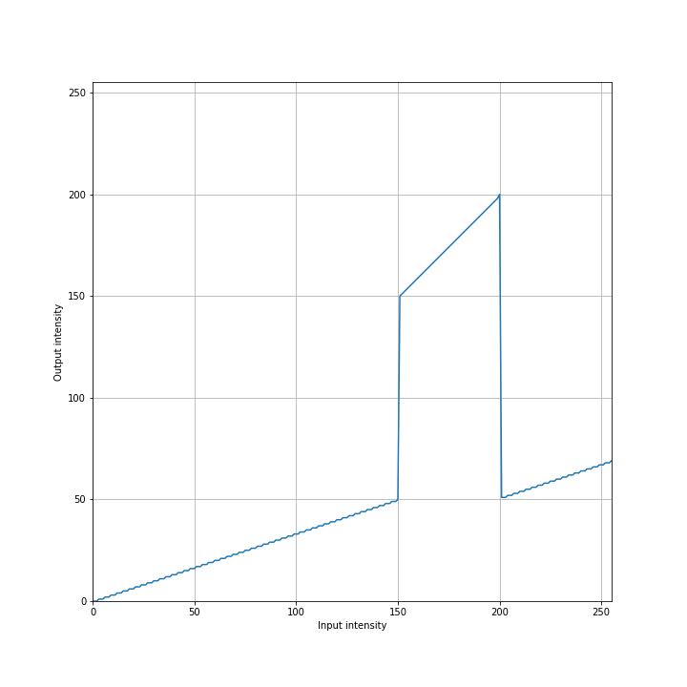

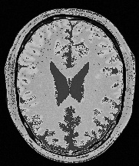2)

t1 = np.linspace(0, 50, 150-0+1).astype('uint8')

t2 = np.linspace(150, 200, 200-150).astype('uint8')

t3 = np.linspace(51, 69, 255 - 200).astype('uint8')

Gary matter enhancing transform

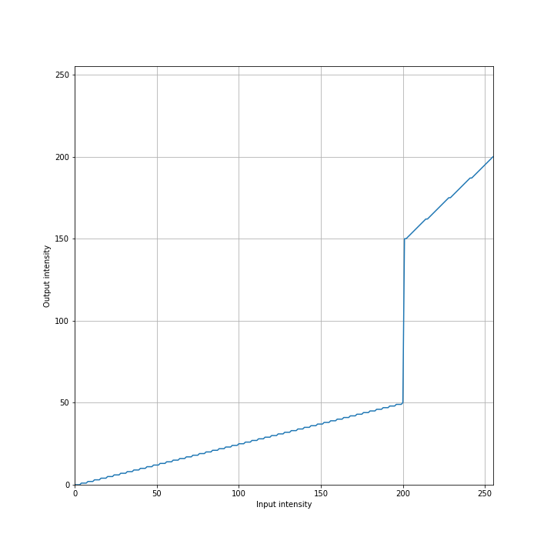

Gary matter enhanced image

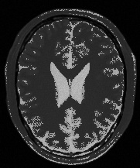

t1 = np.linspace(0, 50, 200-0+1).astype('uint8')

t2 = np.linspace(150, 200, 255-200).astype('uint8')

White matter enhancing transform

3)

White matter enhanced image

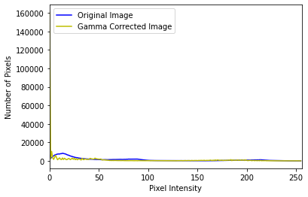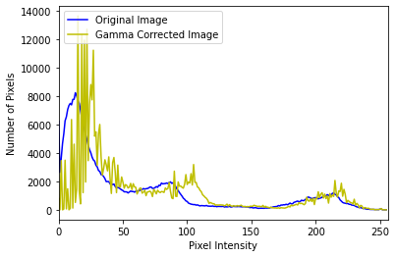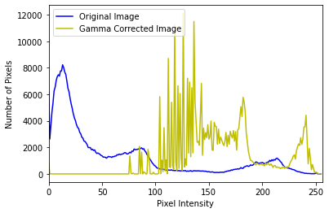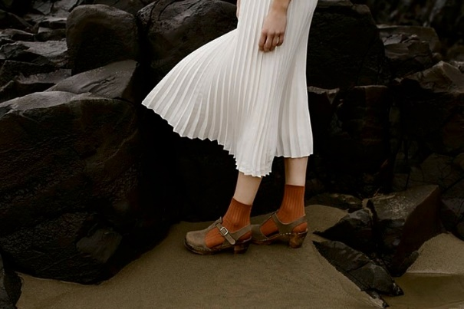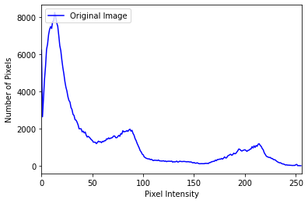

Histogram

Original image

Histogram for Gamma = 0.2

Gamma = 0.2

Histogram for Gamma = 0.8

Gamma = 0.8

Histogram for Gamma = 2

Gamma = 2

The 0.8 is the best choice for gamma value. Image gets brighter for gamma >1 and daker for gamma <1. Gamma values between 0 and 1 expand the range of darker pixels in an image, making it appear brighter by shifting colors that were originally in the middle towards the lighter end while keeping black and white unchanged. Conversely, gamma values greater than 1 have the opposite effect, compressing the range of darker pixels and making the image appear darker.

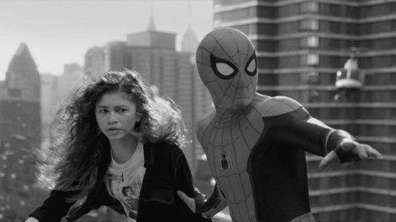4)

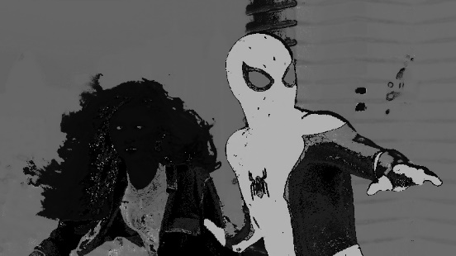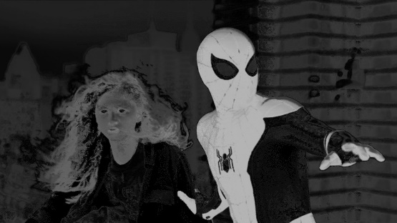.

Saturation image

Hue image

Value image

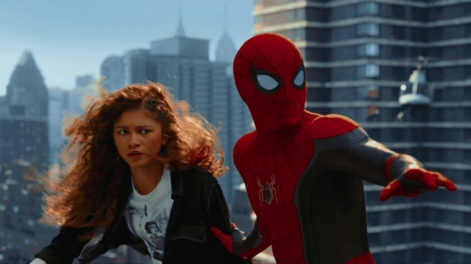

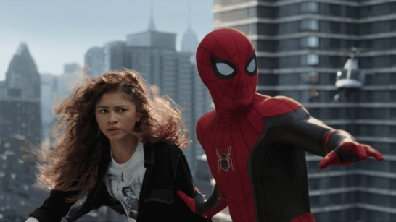

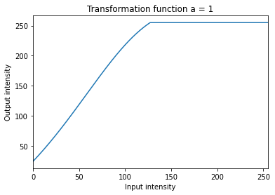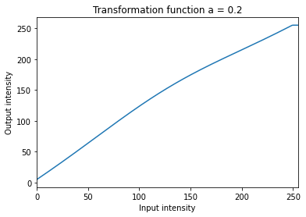

Boosting an image's vibrance involves intensifying the less vibrant colors while keeping the already saturated ones as they are. More precisely, vibrance accentuates subdued colors, typically paying less attention to warmer hues like yellows, oranges, and reds and instead emphasizing cooler colors like blues and greens. The suitable alpha value is 0.5

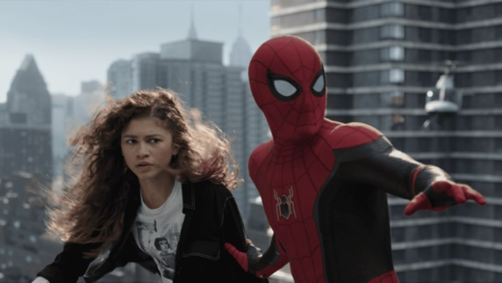

Original image

5)

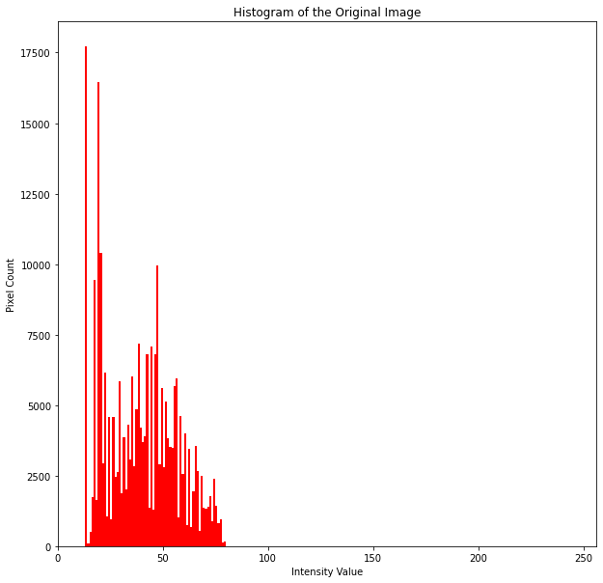

Here are the steps carried out within the function:

1. Calculate the cumulative distribution function (CDF) of the histogram generated.
2. Normalize the cumulative sum.
3. Map equalized pixel intensities to the image pixel intensities using a Look Up table

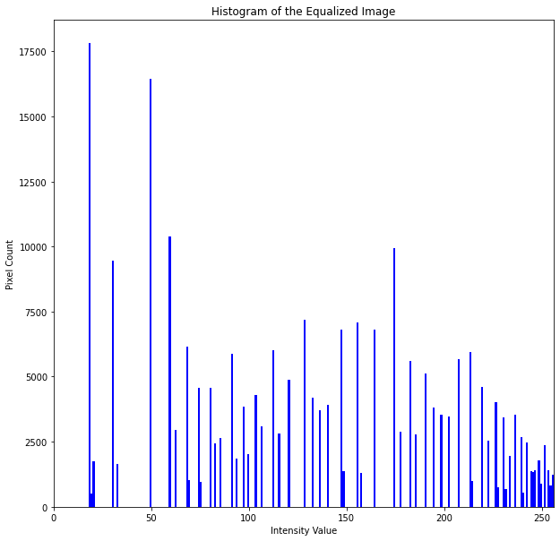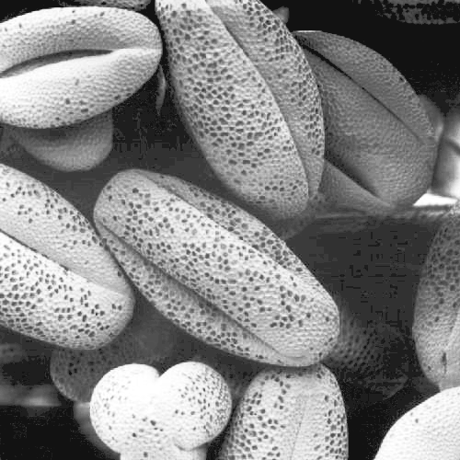

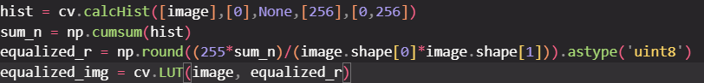

6)

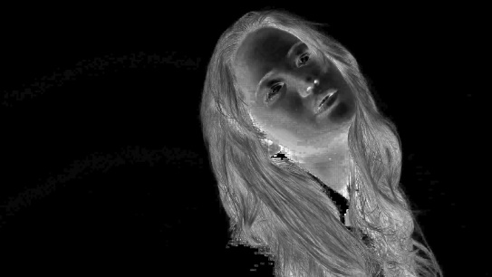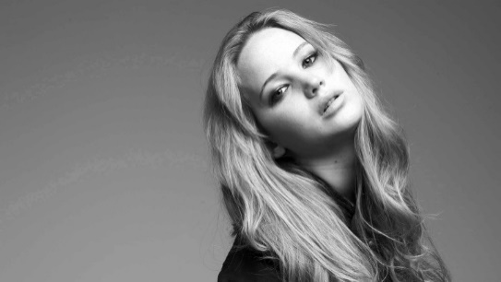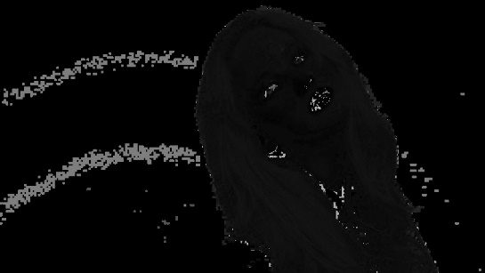

Saturation image

Hue image

Value image

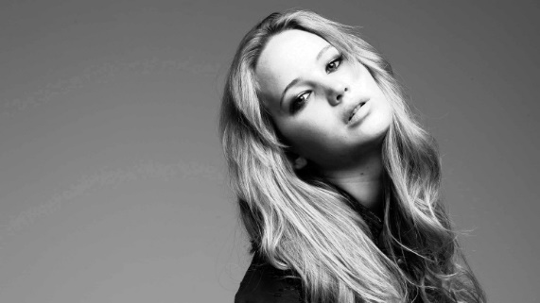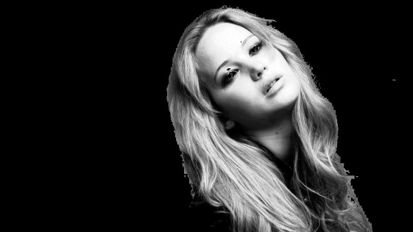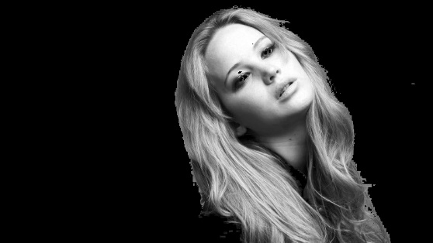

Processed Image

Foreground Equalized Image

Foreground Only image

Generate a threshold to remove the background using bit wise and, then get the background by subtracting foreground from grayscale image. Then add the equalized image to the background.

Cumulative sum

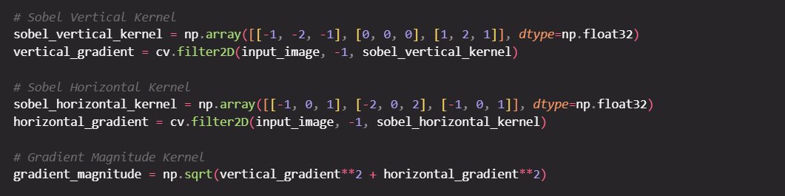7)

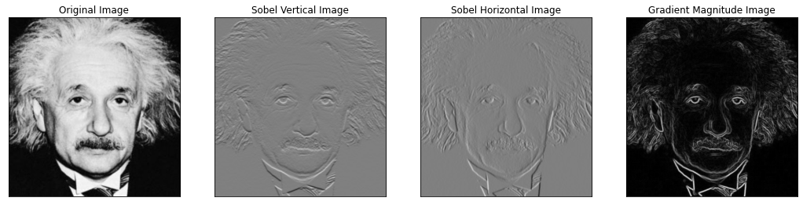

Creating own Sobel filter

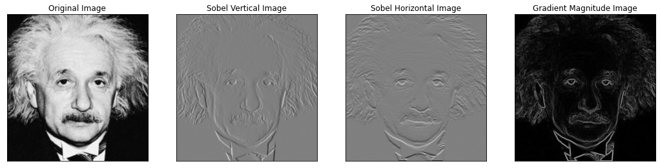

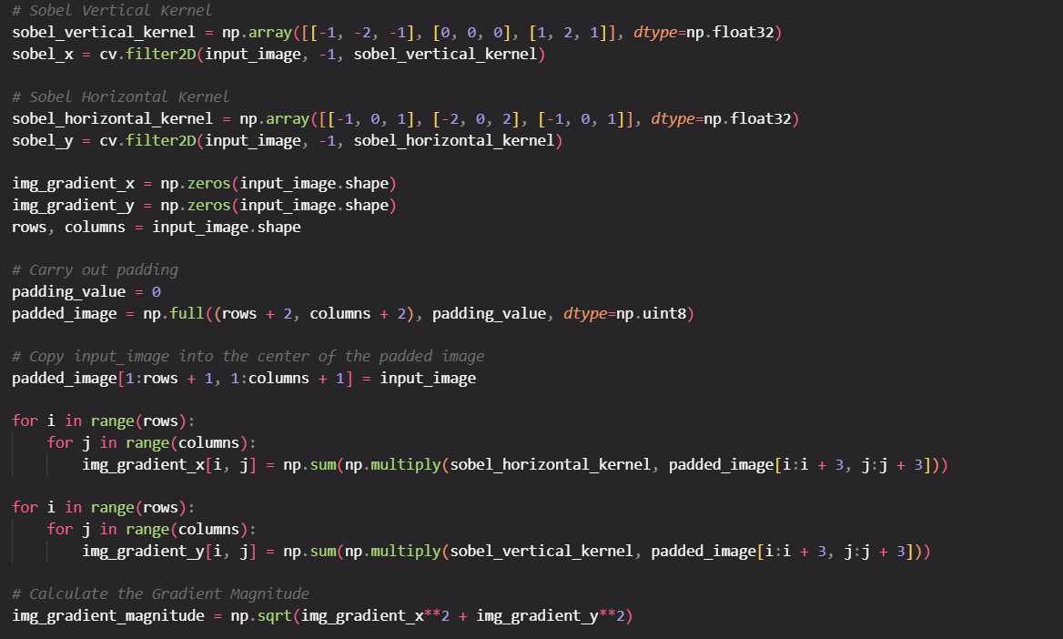

Using the property to make the Sobel filter

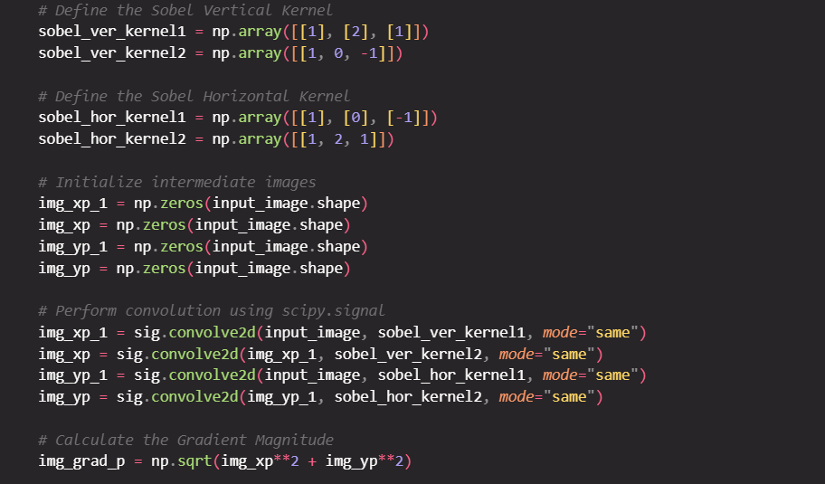



Original large

Bilinear Interpolation

Nearest Neighbor

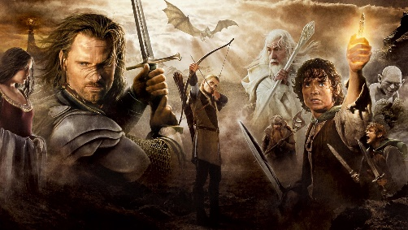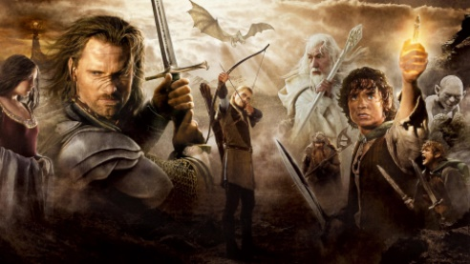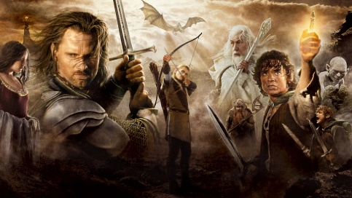8)

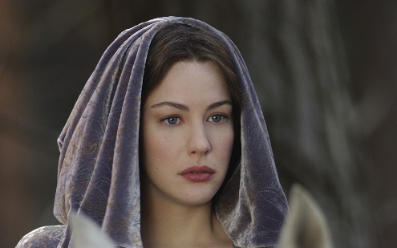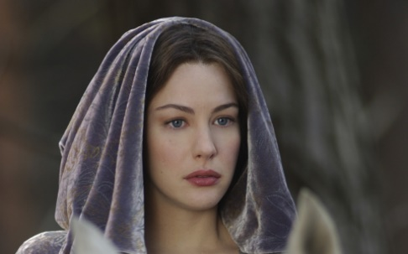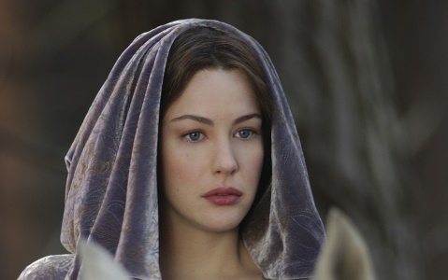

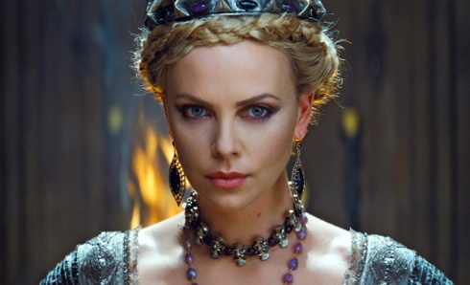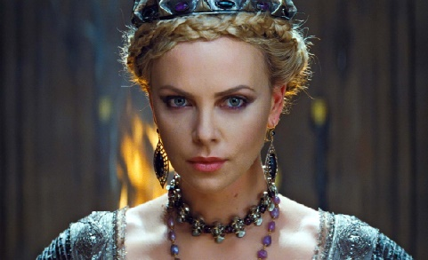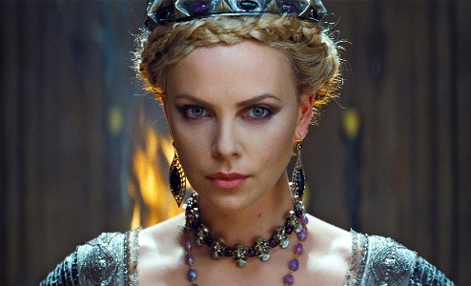

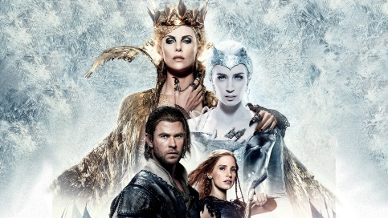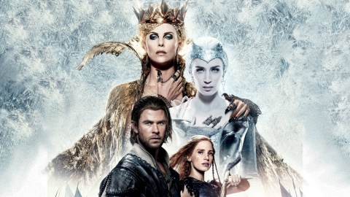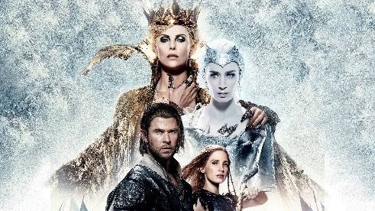



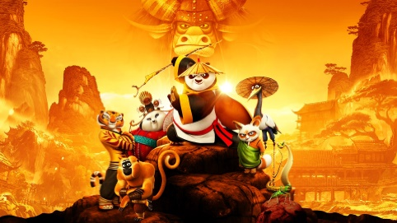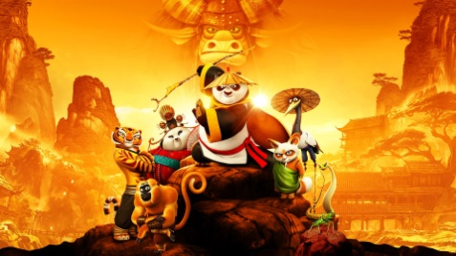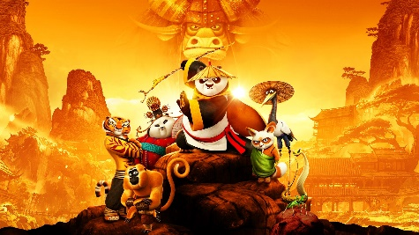

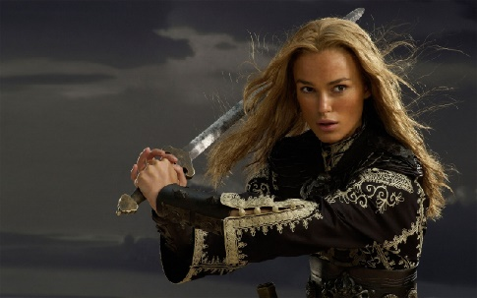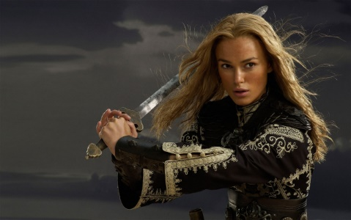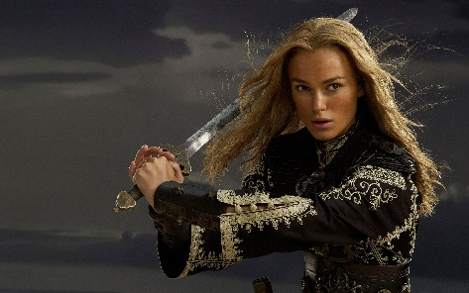

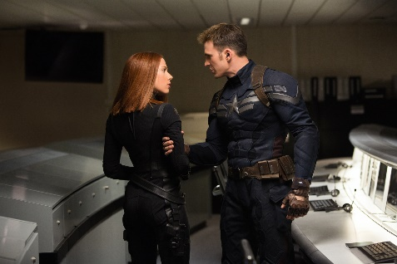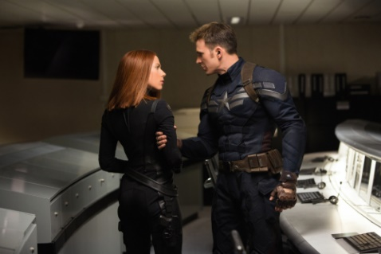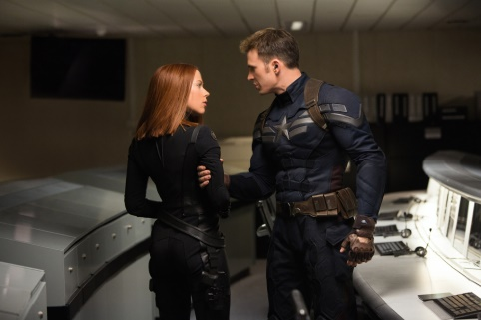



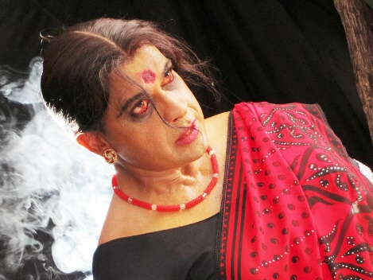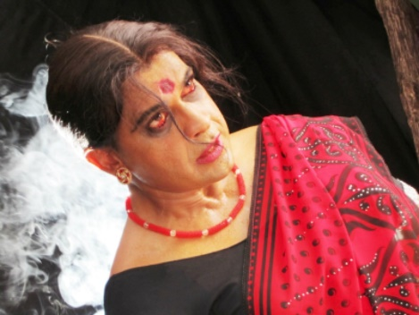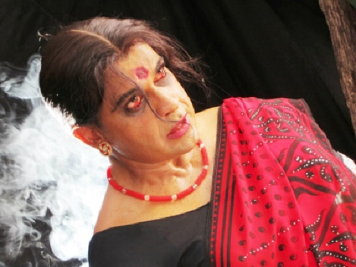



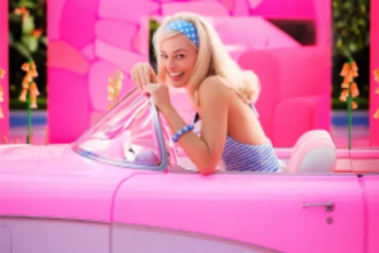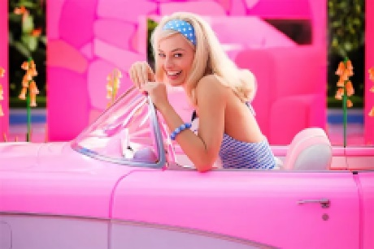

When using Bilinear Interpolation. The Images get a lot smoother

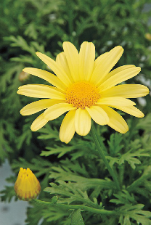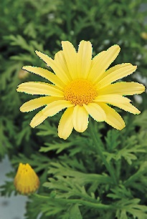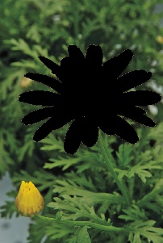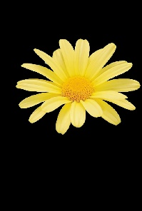9)

When using grabCut, there can be pixels near the image’s edges that potentially belong to both the foreground and background. As a result, when the two images are combined, these edge pixels are added together giving a value higher than 255. These values are automatically mapped back to zero by the OpenCV library, causing them to appear darker.

<https://github.com/HirunaVishwamith/Image-processing-assignmnet-1>

